**Spell check and grammar checks**

* Steps:

1. Launch Word, and either open an already existing document or create a new one from the welcome screen.
2. From the Ribbon on the top of your screen, select the **Review** tab.

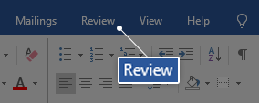

1. In the **Proofing** section, you can see a button that says **Spelling & Grammar**. Click on this to start a manual check.

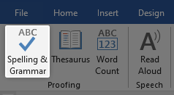

1. If Word is able to detect any spelling issues in the language your document is set to, a new pane will open up on the right side of the application. You can see the error underlined with a red line.

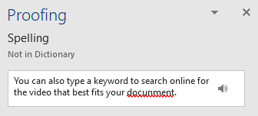

1. 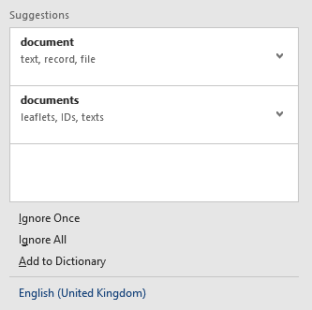You’ll see suggested words with definitions that allow you to select the correct spelling of the word you were trying to type. To implement any of these suggestions, simply click on them.
2. 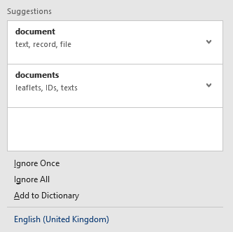You also have the option to make Word ignore the presumably misspelled word or words by pressing **Ignore Once** or **Ignore All** under the suggestions. You can also **Add to Dictionary**, meaning that the word in question won’t get detected by as a misspelling in the future.
3. After you deal with the first misspelled word, you can move on to the next one if any more have been detected.

**Tip**: You can use a shortcut to activate the manual spelling and grammar check in Word. Simply press the **F7** key on your keyboard, and the application will automatically perform a spelling and grammar check.